# Deskfood Inc.

# BCS430W Senior Project

# -Jonathon A Carrera(JC)

# -Julia Brand (JB)

# -Justin Smeding (JS)

# -Jerald Figuracion(JF)

# -Gerson Perez Chavarria (GC)

Table of Contents

**DeskFood Inc. Cover page1**

**Table of contents2**

Table of contents continued3

**System Access4**

How to run the API4

**Project Description**5

**User stories, sprint** 1,2,3,46

**Sprint 5, Product backlog**7

**Sprint Retrospective, Sprint 1,28**

Sprint 3, 4 9

**Context diagram10**

**Physical Data Flow Diagram11**

Physical entity relationship diagram12

**Interface Prototype sketches**1**3**

1. Login and registration button13
2. Registration form13
3. Choosing of Store13
4. Location when ordering13
5. Kitchen Selection14
6. Runner selection for order for pickup14
7. Updates to orders14
8. Check out/payment14

**Completed test plan15**

Completed System Images A. Login and registration button16

B. Kitchen’s choices of editing17

C. Editing of Deli menu18

D. Choice of ordering or delivering food**19**

E. Order details 20

F. Order status21

G. Registration Page22

H. Pick an order page **23**

I. Order details**24**

J. Form of Payment**25**

K. Payment Page continued**26**

L. Ordering page**27**

M. Ordering confirmation**28**

System Access

Requirements to run this Project:

1. Python 3.9 or Higher Installed
2. Pyrebase4 Module Installed
3. PyQt5 Module Installed
4. FastAPI Module Installed
5. Uvicorn Module Installed

Module Installation Commands:

* pip install pyrebase4
* pip install PyQt5
* pip install fastapi
* pip install uvicorn

How to run the project:

1. Run the API

To run the API first change directory (CD) into the “Backend” folder of the project than use the following line to run the GUI:

***Python -m uvicorn DeskFoodAPI:app –reload***

1. Run the GUI:

Open a new terminal and change directory (CD) into the “Frontend” folder than use the following line to run the GUI:

***Python Main.py***

Project Description

Problem

The problem the team has decided to take on is that of food delivery within the campus that allows users of the campus community to get food without having to walk across campus to wait in lines and taking all that time between their classes during the week to get food.

Solution

The solution to the problem would result in more time for the students and would likely save their time that could be spent studying or perform other activities. The application the team will build would list complete menus from on campus locations. The application would require a valid RAMID and would not let non-students register for it. The food users wish to be delivered would be carried by a fellow student that would know the layout of the college and could take the fastest routes to ensure a speedy and warm delivery. This application would also help students that would want to make extra money while waiting for class or just in general while at school.

User Stories

Sprint 1

-No user stories completed during this sprint.

Sprint 2

-As a customer, I would like to see a list of venues in the campus Centre. examples: the grill, the sushi station, freshens, salads, sandwiches, pizza, also can all ala carte item. (JC,JS,GC)

-As a Customer I would like to see a list of items for whatever store I chose.(JF,GC,JC)

Sprint 3

- As the Kitchen, I would like the ability to add items to my menu.(JC,JS)

- As the Kitchen, I would like to update the availability of an item.(JF,JC)

- As the Kitchen, I would like to update the price of an item.(GC,JF,JC)

- As the Kitchen, I would like to be able to remove items from the menu.(JC,JB)

- As a Customer I would like to login to my account.(JC)

- As a Customer I would like to be able to register for a new account.(GC,JC)

Sprint 4

- As an Admin/Kitchen I do not want customers / runners to have the option to edit any feature of a kitchen.(JS)

- As an Admin/Kitchen I want to see a different screen than other users when I log in. This screen should have a list of options that I can use to change aspects of a kitchen.(JS)

- As a customer, I want to be able to select items for my order.(JS)

- As a customer, I want to see what my total order will cost before finalizing and putting the order through.(JC,JS)

- As a customer, I would like to receive the order updates of my order (preparing order, ready for pickup, and out for delivery.). (JF,JC)

- As a customer, I want to be able to pay for the food and delivery on the system.(JF)

Sprint 5

-As a Runner, I would like to send order updates (on the way or delivered) to the customer.

-As the Kitchen, I would like to see a list the orders that need to be made and their details such as special instructions.

-As the Kitchen, would like to be able to update status that order is ready for pickup.

-As a customer, I would like to receive an order confirmation for the order I placed that shows me the details of my order. (Order Number, total, list of items, etc).

-As a Runner I would like to see a list of Orders that are Ready for Pick Up.

-As a delivery person, I would like to receive the customer’s location for drop off.

-As a delivery person, I would like to be able to record that the delivery is complete.

-As a delivery person, I would like to receive the status of the food from the kitchen

Product Backlog

-As a delivery person, I would like to be able to record in the system that item is picked up and put in an ETA for delivery- As a delivery person, I would like to be able to record that the delivery is complete.

-As a customer, I would like to indicate that the order is going to be picked up by me and does not require delivery.

-As a customer, I would like to have a profile that stores my payment information, so I don’t have to enter it every time.

-As a customer, I would like to have a profile that stores my payment information, so I don’t have to enter it every time.

-As a customer, I want to be able to modify the order at the last step to add or take something off

-As a customer, I want to be able to edit items and add special instructions.

Sprint Retrospectives

Sprint 1

Sprint 2

Sprint 3

Sprint 4

Context Diagram

Physical Data Flow Diagram

Physical entity Relationship diagram

Interface prototype sketches

1. Login and registration button
2. Registration form
3. Choosing of store
4. Location where ordering

Sketches continued

1. Kitchen selection
2. Runner selection for order for pickup
3. Updates to orders
4. Check out / payment

Completed test plans

Completed system images

1. Login and registration button

1. Kitchen’s choices of editing

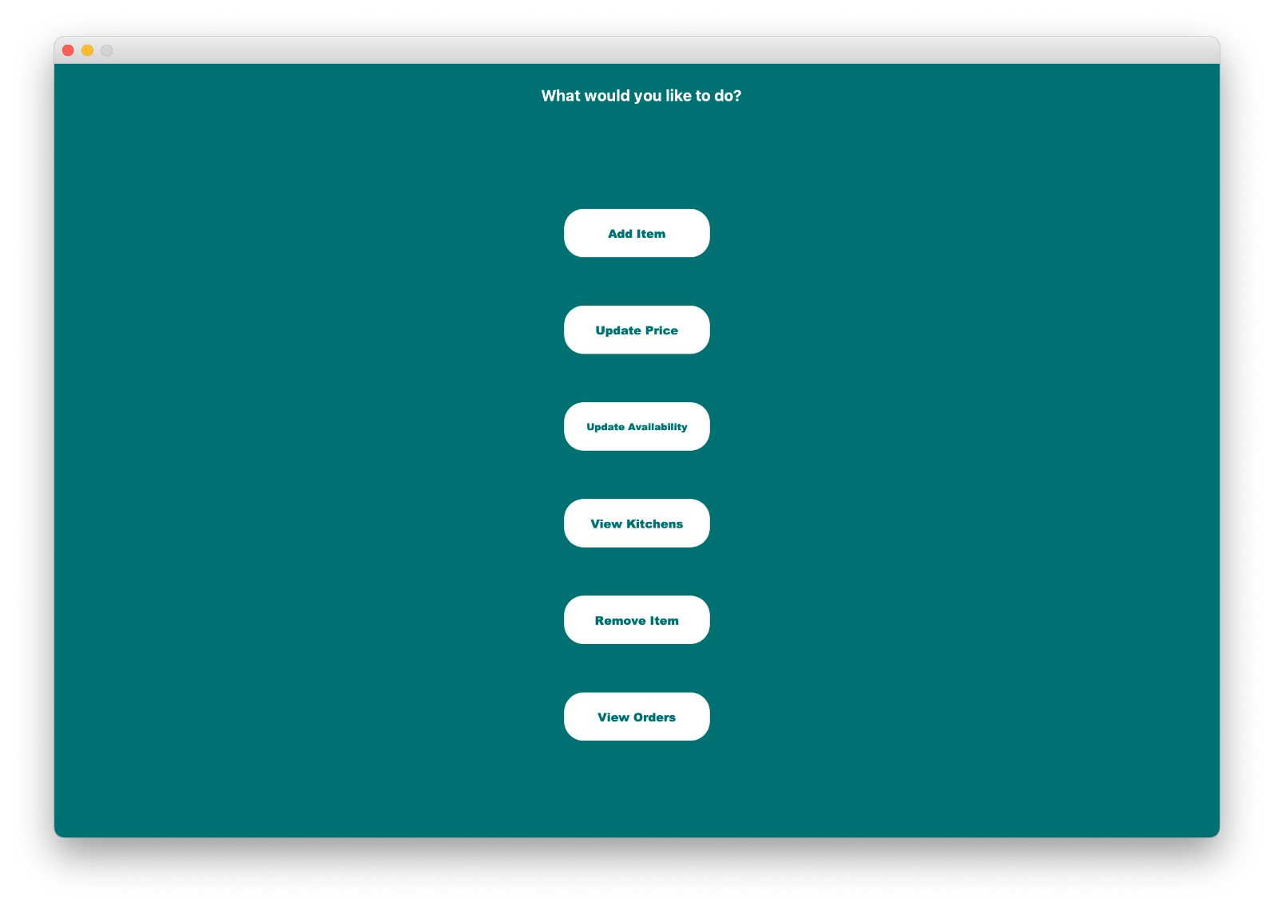

C. Editing of Deli menu

1. choice of ordering or delivering food

1. order details 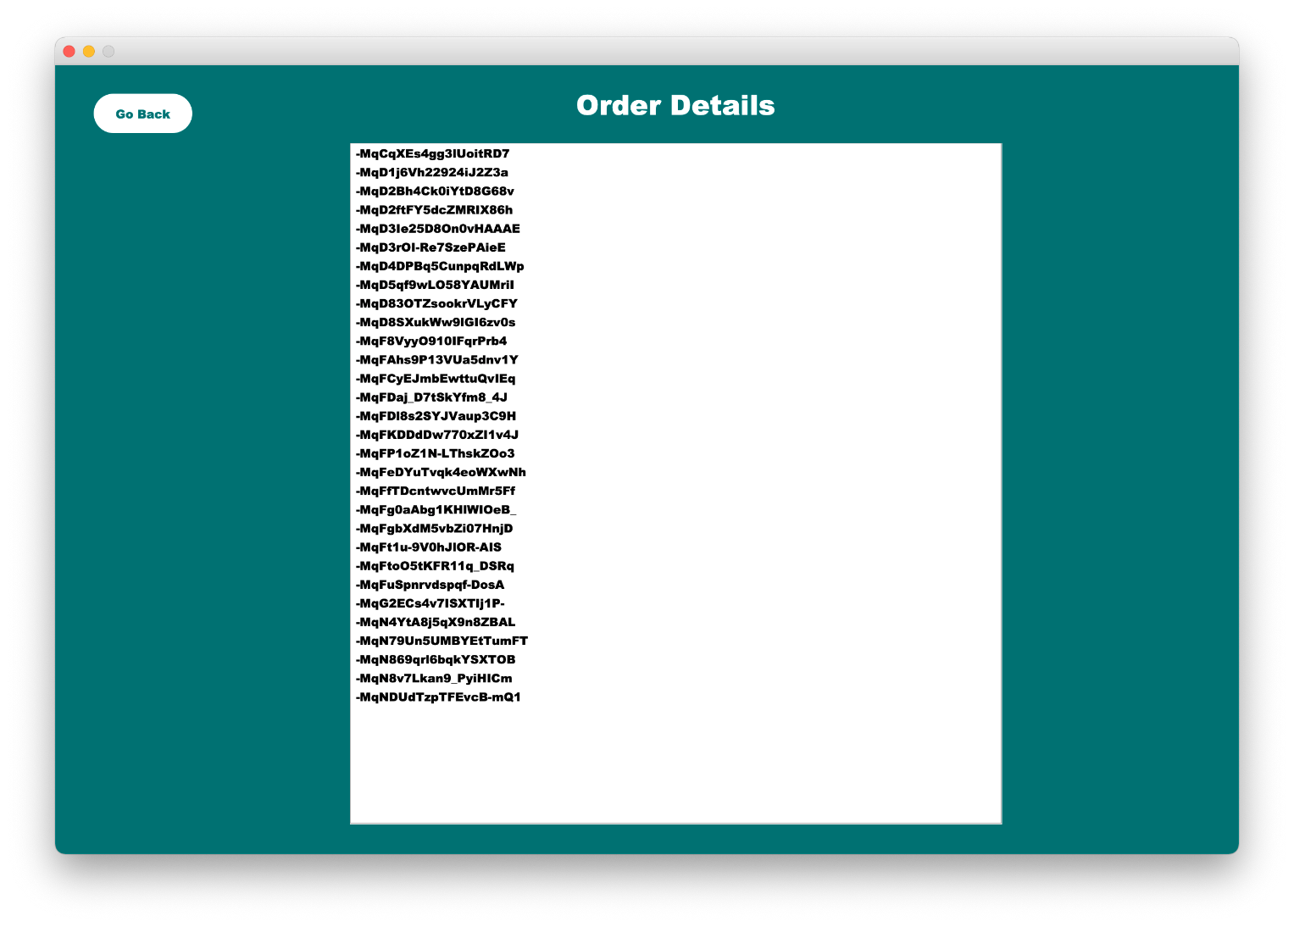
2. Order status

1. Registration Page

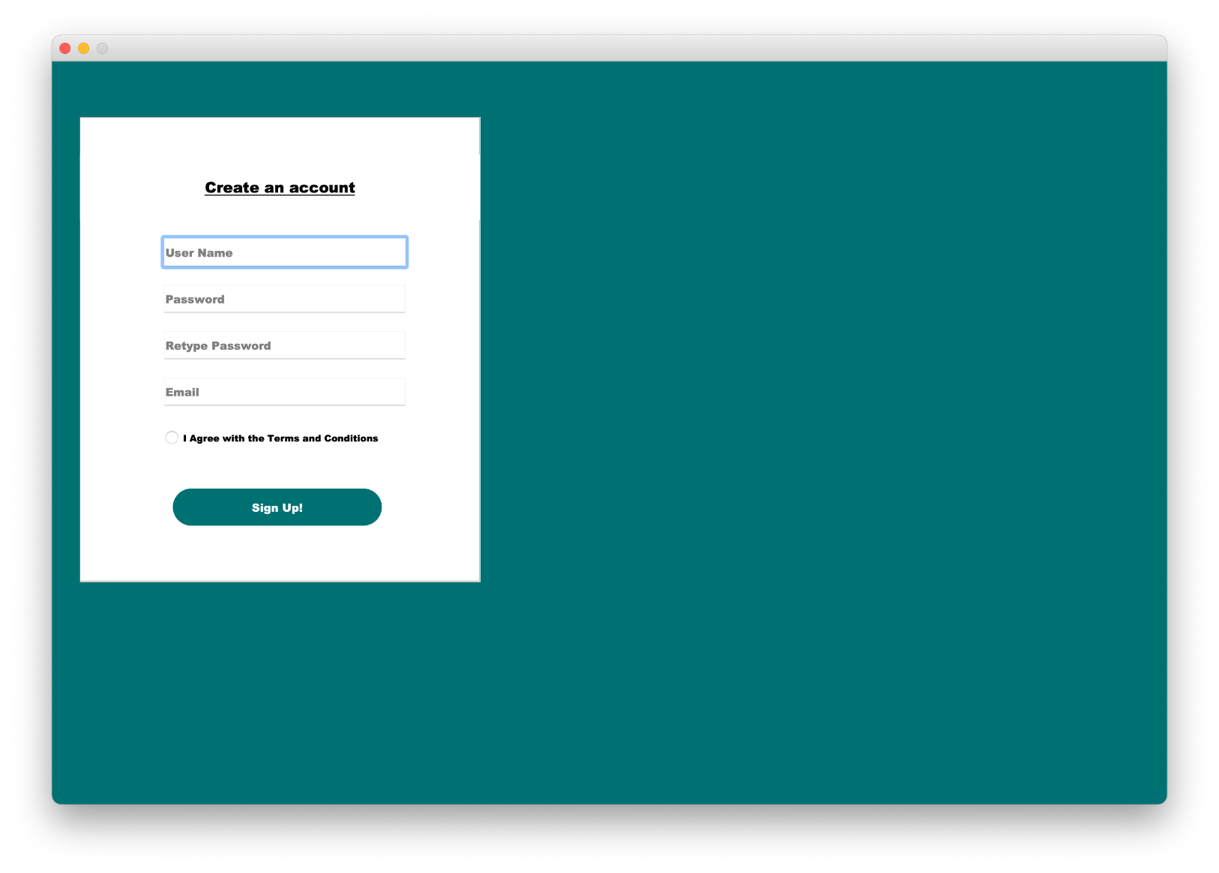

1. Pick an order page

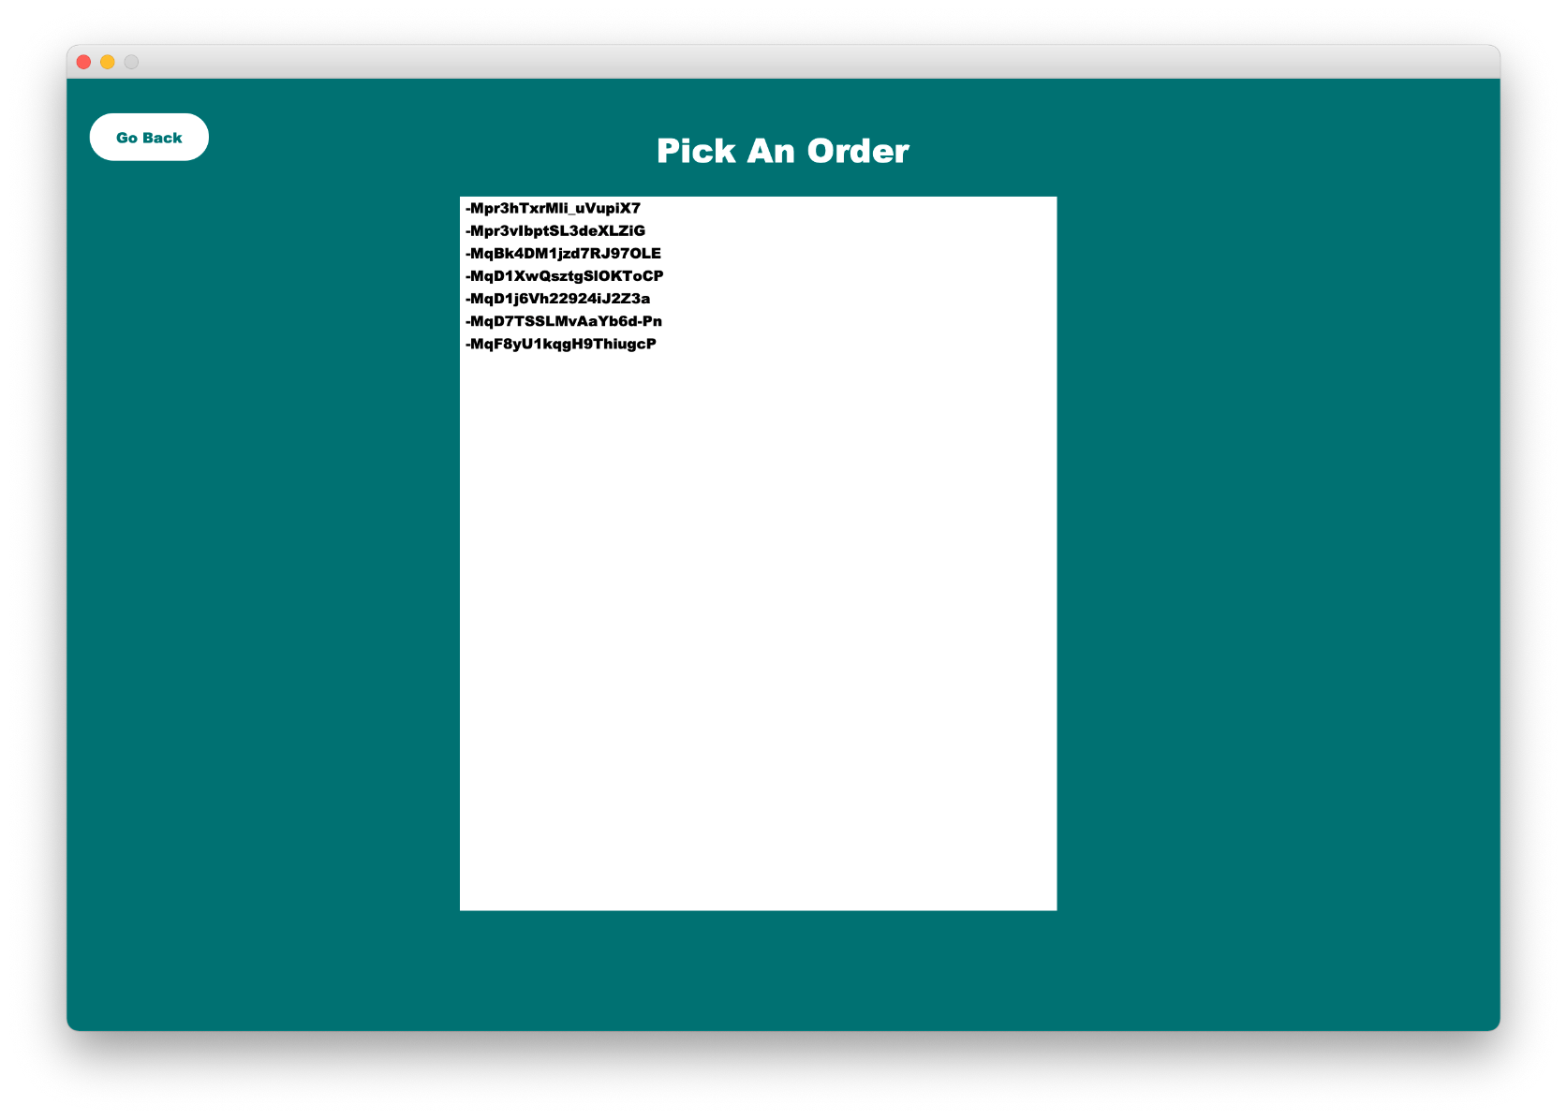

1. Order details

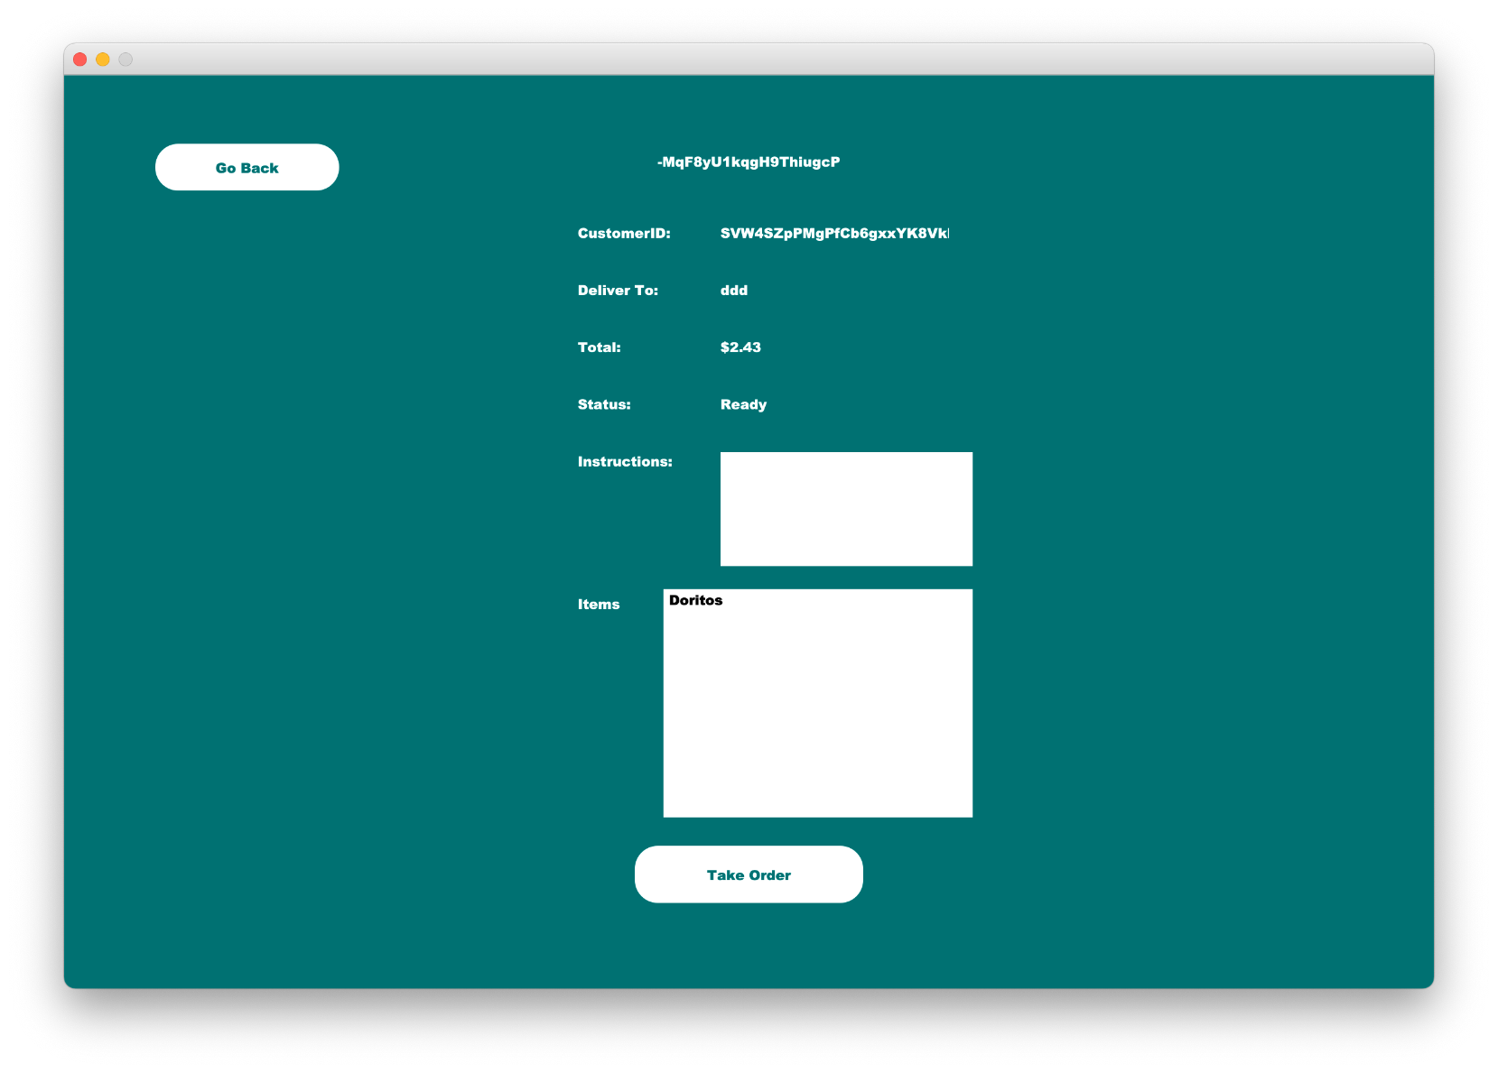

1. Form of page

1. Payment page continued

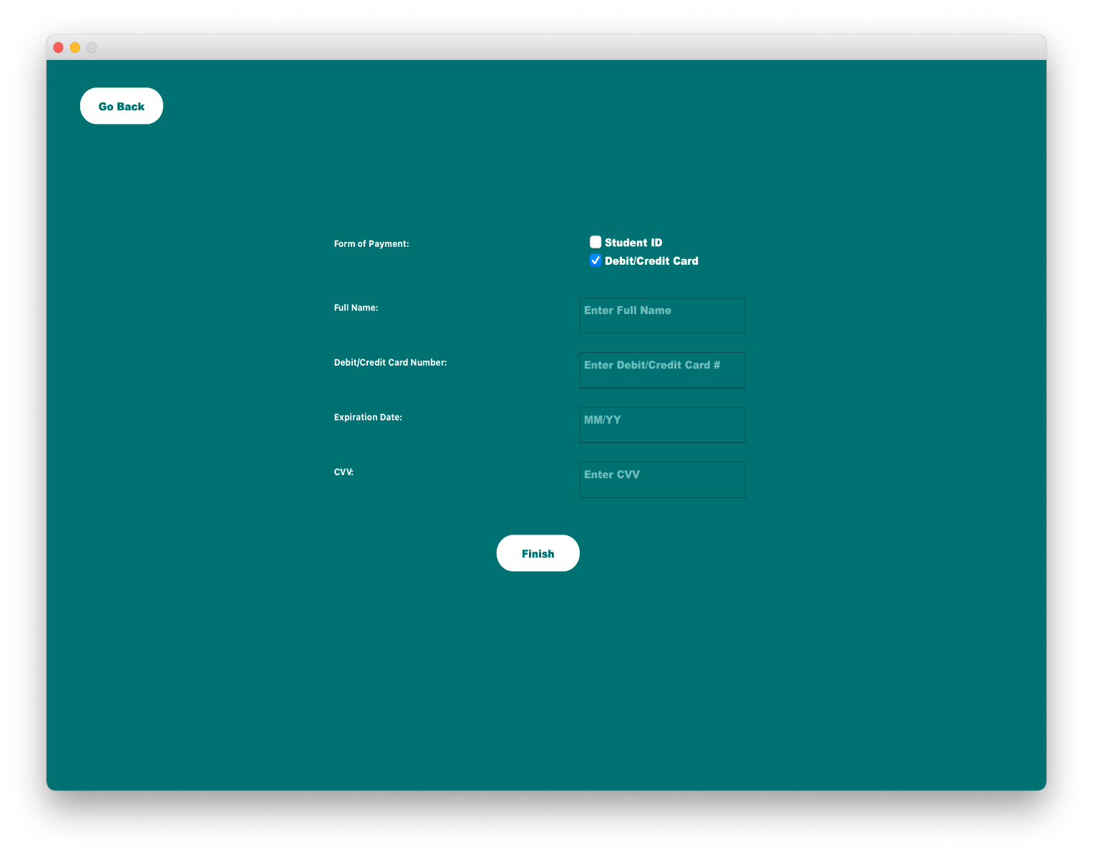

L. Ordering page

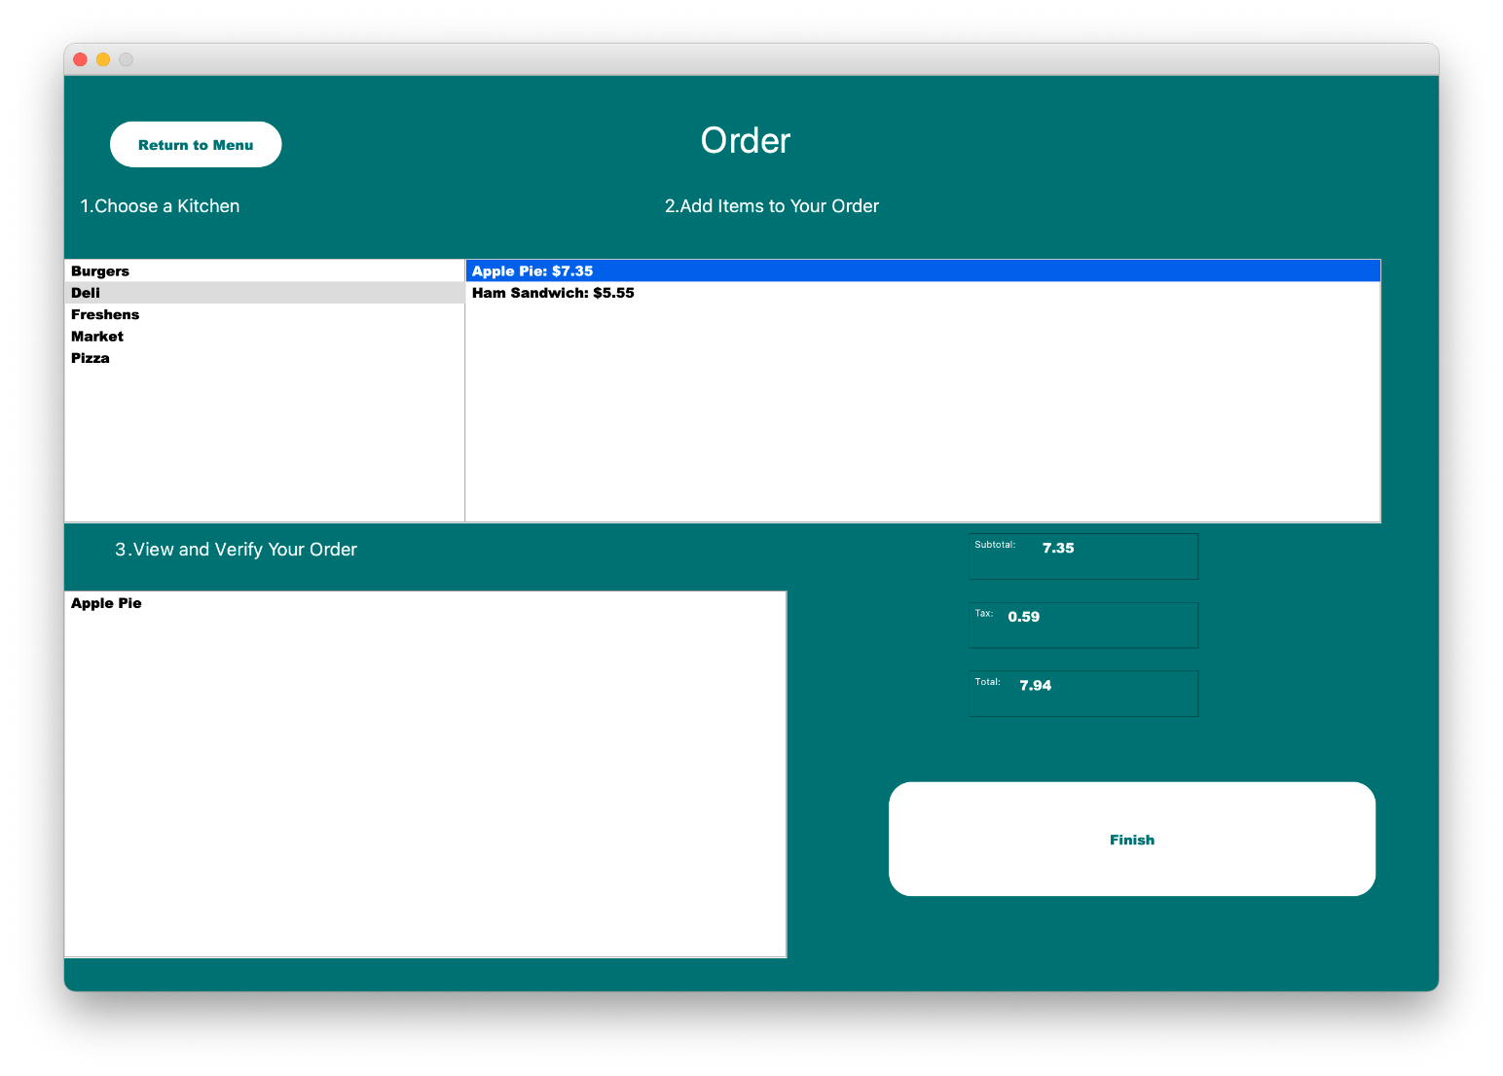

M. Ordering confirmation 